**Practical No. 12: Write a program to demonstrate the use of JTextField and JPassword using Listener Interface.**

**Exercise:**

1. **Write a program using JPasswordField and JTextField to demonstrate the use of user authentication.**

**Program:**

import java.awt.*;

//import java.applet.*;

import javax.swing.*;

import java.awt.event.*;

public class pract12_ex1 extends JFrame implements ActionListener

{JTextField jp = new JPasswordField(15);

    JTextField jt = new JTextField(15);

    String pass = "NESP";

    String msg;

    JLabel l1 , l2,l3= new JLabel("");

    JButton b = new JButton("Submit");

    pract12_ex1()

    {setVisible(true);

        setSize(300,300);

        setLayout(new FlowLayout());

        l1 =  new JLabel("Username : ");

        add(l1);

        add(jt);

        l2 = new JLabel("Password : ");

        add(l2);

        add(jp);

        add(b);

        add(l3);

       jp.addActionListener(this);

       b.addActionListener(this);

    }

    public void actionPerformed(ActionEvent e)

    {if(e.getSource() == b)

        {String s = jp.getText();

            if(s == pass)

            {msg ="Authentication Successful...";

                l3.setText(msg);

            }

            else

            {msg= "Authentication Failed";

                l3.setText(msg);

            }}}

    public static void main(String[] args) {

        new pract12_ex1();}}

**Output:**

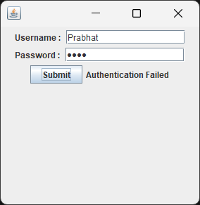

1. **Write a program using JTextField perform the addition of two numbers.**

**Program:**

import java.awt.*; import java.awt.event.*;

import javax.swing.*;

import java.applet.*;

public class pract12_ex2 extends JApplet implements ActionListener

 { JTextField jtf1,jtf2,jtf3;

JButton jb; JLabel jl1,jl2,jl3;

public void init() {

Container c = getContentPane();

c.setLayout(new GridLayout(4,2));

jtf1 = new JTextField();

jtf2 = new JTextField();

jtf3 = new JTextField();

jb = new JButton("Addition");

 jl1 = new JLabel("Number 1",JLabel.CENTER);

jl2 = new JLabel("Number 2",JLabel.CENTER);

jl3 = new JLabel("Answer",JLabel.CENTER);

jb.addActionListener(this);

c.add(jl1);

 c.add(jtf1);

c.add(jl2);

c.add(jtf2);

c.add(jl3);

c.add(jtf3);

c.add(jb);

}

public void actionPerformed(ActionEvent ae)

 {

String s1 = jtf1.getText();

String s2 = jtf2.getText();

int i1 = Integer.parseInt(s1);

int i2 = Integer.parseInt(s2);

int mult = i1+i2;

String ans = Integer.toString(mult);

jtf3.setText(ans);

repaint(); } }

/* <applet code=pract12_ex2.class width=400 height=400>

 </applet>*/

**Output:**

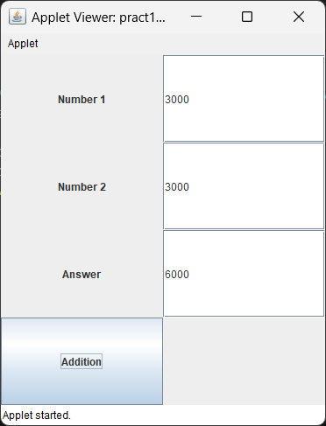

1. **Write a program using JPasswordField to accept password from user and if the length is less than 6 characters then error message should be displayed “Password length must be >6 characters”.**

**Program:**

import java.awt.*;

import javax.swing.*;

import java.awt.event.*;

public class pract12_ex3 extends JFrame implements ActionListener

{JLabel l1 ;

    JPasswordField jp = new JPasswordField(15);

    JButton b = new JButton("Submit");

    String msg = "";

    JLabel l2;

    pract12_ex3()

    {setVisible(true);

        setSize(300,300);

        setLayout(new FlowLayout());

        l1 = new JLabel("Password : ");

        add(l1);

        add(jp);

        add(b);

        l2 = new JLabel("");

        add(l2);

        b.addActionListener(this);}

    public void actionPerformed(ActionEvent e)

    {if(e.getSource() == b)

        {String s = jp.getText();

            if(s.length()<6)

            {msg = "Password length must be grater than 6";

               l2.setText(msg);

            }

            else

            {

                msg = "Correct password length";

                l2.setText(msg);

            }} }

public static void main(String[] args) {

        new pract12_ex3();

    }}

**Output:**

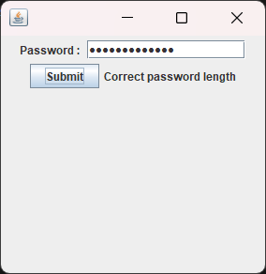

**Program Code:**

import java.awt.*;

import javax.swing.*;

import java.applet.*;

public class pract12_X extends JFrame

{pract12_X()

    {setVisible(true);

        setSize(300,300);

        setLayout(new FlowLayout());

        JLabel l = new JLabel("Password : ");

        JPasswordField jp = new JPasswordField(20);

        jp.setEchoChar('#');

        add(l);

        add(jp);}

    public static void main(String[] args) {

        new pract12_X();}}

**Output:**

